ELCOT

projects

By M.MALATHI

SIMPLE TALLY LEDGER CREATION

* PROBLEM NO 1
* ON APRIL 1, 2020 BUSINESS STARTED WITH CASH RS 65000,FURNITURE RS 20000,AND BUILDINGS RS 100000
* ON APRIL 1, 2020 GOODS PURCHASED FROM ASIF ON CREDIT RS 15000
* ON APRIL 1, 2020 GOODS PURCHASED ON CASH RS 30000
* ON APRIL 1,2020 GOODS SELL TO THE CUSTOMER AND CASH RECEIVED RS 22000
* ON APRIL 1,2020 GOODS WORTH RS 14000 SELL TO SHAHID
* ON APRIL 1,2020 TYPEWRITER WORTH RS 8000 BOUGHT ON CASH
* ON APRIL 1,2020 OFFICE EQUIPMENT PURCHASED ON CASH RS 4000

|  |  |  |  |  |
| --- | --- | --- | --- | --- |
| DATE | DETAILS | ENTRY | AMOUNT | VOUCHER |
| 1.4.2020 | COMMENCED BUSINESS | CASH A/C  FURNITURE A/C  BUILDINGS A/C DR  TO CAPITAL A/C | 65000  20000  100000  185000 | RECEIPT(F6) |
| 1.4.2020 | PURCHASE GOODS FROM ASIF ON CREDIT | PURCHASE A/C DR  TO ASIF A/C | 15000  15000 | PURCHASE (F9) |
| 1.4.2020 | PURCHASE GOODS ON CASH | PURCAHSE A/C DR  TO CASH A/C | 30000  30000 | PURCHASE(F9) |
| 1.4.2020 | SELLING GOODS | CASH A/C DR  TO SALES A/C | 22000  22000 | SALES (F8) |

|  |  |  |  |  |
| --- | --- | --- | --- | --- |
| 1.4.2020 | GOODS SELL ON CREDIT | SHAHID A/C DR  TO SALES A/C | 14000  14000 | SALES(F8) |
| 1.4.2020 | TYPEWRIGHTER BOUGHT FOR 8000 | TYPEWRITER A/C DR  TO CASH A/C | 8000  8000 | PAYMENT(F5) |
| 1.4.2020 | OFFICE EQUIPMENT BOUGHT | OFFICE EQUIPMENT A/C DR  CASH A/C | 4000  4000 | PAYMENT(F5) |
|  |  |  |  |  |

|  |  |  |  |  |  |
| --- | --- | --- | --- | --- | --- |
| DATE | PARTICULARS J.F | AMOUNT | DATE | PARTICULARS J.F | AMOUNT |
| APR 1 | TO CAPITAL | 65000 | APR 1 | BY PURCHASE A/C | 30000 |
| APR 1 | TO SALES | 22000 | APR 1 | BY TYPE WRITER | 8000 |
|  |  |  | APR 1 | BY OFFICE EQUIPMENT | 4000 |
|  |  |  |  | BY BALANCE C/D | 45000 |
|  |  | 87000 | FURNITURE ACCOUNT |  | 87000 |

CASH ACCOUNT

LEDGER

|  |  |  |  |  |  |  |  |
| --- | --- | --- | --- | --- | --- | --- | --- |
| DATE | PARTICULARS | J.F | AMOUNT | DATE | PARTICULARS | J.F | AMOUNT |
| APR 1 | TO CAPITAL |  | 20000 |  | BY BALANCE C/D |  | 20000 |
|  |  |  | 20000 |  |  |  | 20000 |

BUILDING ACCOUNT

|  |  |  |  |  |  |  |  |
| --- | --- | --- | --- | --- | --- | --- | --- |
| DATE | PARTICULARS | J.F | AMOUNT | DATE | PARTICULARS | J.F | AMOUNT |
| APR 1 | TO CAPITAL |  | 100000 |  | BY BALANCE C/D |  | 100000 |
|  |  |  | 100000 |  |  |  | 100000 |

CAPITAL ACCOUNT

|  |  |  |  |  |  |  |  |
| --- | --- | --- | --- | --- | --- | --- | --- |
| DATE | PARTICULARS | J.F | AMOUNT | DATE | PARTICULARS | J.F | AMOUNT |
|  | BY BALANCE C/D |  | 185000 | APR 1 | BY CASH  BY FURNITURE  BY BUILDING |  | 65000  20000  100000 |
|  |  |  | 185000 |  |  |  | 185000 |

PURCHASE ACCOUNT

|  |  |  |  |  |  |  |  |
| --- | --- | --- | --- | --- | --- | --- | --- |
| JAN 1 | ASIF’S A/C |  | 15000 |  |  |  |  |
| JAN 1 | CASH A/C |  | 30000 |  | BY BALANCE C/D |  | 45000 |
|  |  |  | 45000 |  |  |  | 45000 |

ASIF ACCOUNT

|  |  |  |  |  |  |  |  |
| --- | --- | --- | --- | --- | --- | --- | --- |
| DATE | PARTICULARS | J.F | AMOUNT | DATE | PARTICULARS | J.F | AMOUNT |
|  | TO BALANCE C/D |  | 15000 | APR 1 | BY PURCHASE A/C |  | 15000 |
|  |  |  | 15000 |  |  |  | 15000 |

SHAHID ACCOUNT

|  |  |  |  |  |  |  |  |
| --- | --- | --- | --- | --- | --- | --- | --- |
| DATE | PARTICULARS | J.F | AMOUNT | DATE | PARTICULARS | J.F | AMOUNT |
| APR 1 | TO SALES A/C |  | 14000 |  | BY BALANCE C/D |  | 14000 |
|  |  |  | 14000 |  |  |  | 14000 |

SALES ACCOUNT

|  |  |  |  |  |  |  |  |
| --- | --- | --- | --- | --- | --- | --- | --- |
|  |  |  |  |  |  |  |  |
|  |  |  |  |  |  |  |  |
|  |  |  |  |  |  |  |  |
|  |  |  |  |  |  |  |  |
|  |  |  |  |  |  |  |  |

|  |  |  |  |  |  |  |  |
| --- | --- | --- | --- | --- | --- | --- | --- |
| DATE | PARTICULARS | J.F | AMOUNT | DATE | PARTICULARS | J.F | AMOUNT |
|  |  |  |  | APR 1 | BY CASH A/C |  | 22000 |
|  |  |  |  | APR 1 | BY SHAHID A/C |  | 14000 |
|  | TO BALANCE C/D |  | 36000 |  |  |  |  |
|  |  |  | 36000 |  |  |  | 36000 |

TYPEWRITER ACCOUNT

|  |  |  |  |  |  |  |  |
| --- | --- | --- | --- | --- | --- | --- | --- |
| DATE | PARTICULARS | J.F | AMOUNT | DATE | PARTICULARS | J.F | AMOUNT |
| APR 1 | TO CASH A/C |  | 8000 |  | BY BALANCE C/D |  | 8000 |
|  |  |  | 8000 |  |  |  | 8000 |

OFFICE EQUIPMENT ACCOUNT

|  |  |  |  |  |  |  |  |
| --- | --- | --- | --- | --- | --- | --- | --- |
| DATE | PARTICULARS | J.F | AMOUNT | DATE | PARTICULARS | J.F | AMOUNT |
| APR 1 | TO CASH A/C |  | 4000 |  | BY BALANCE C/D |  | 4000 |
|  |  |  | 4000 |  |  |  | 4000 |

TRIAL BALANCE

|  |  |  |
| --- | --- | --- |
| PARTICULARS | DEBIT | CREDIT |
| CASH | 45000 |  |
| FURNITURE | 20000 |  |
| BUIDING | 100000 |  |
| CAPITAL |  | 185000 |
| PURCHASE | 45000 |  |
| ASIF |  | 15000 |
| SHAHID | 14000 |  |
| SALES |  | 36000 |
| TYPEWRITER | 8000 |  |
| OFFICE EQUIPMENT | 4000 |  |
|  |  |  |
| TOTAL AMOUNT | 236000 | 236000 |

PROFIT AND LOSS ACCOUNT

TRADING ACCOUNT

|  |  |  |  |  |  |
| --- | --- | --- | --- | --- | --- |
| DATE | PARTICULARS | AMOUNT | DATE | PARTICULARS | AMOUNT |
| JAN 1 | TO PURCHASE | 45000 |  | BY SALES | 36000 |
|  |  |  |  | BY BALANCE C/D (GROSS LOSS) | 9000 |
|  |  | 45000 |  |  | 45000 |

|  |  |  |  |  |  |
| --- | --- | --- | --- | --- | --- |
| DATE | PARTICULARS | AMOUNT | DATE | PARTICULARS | AMOUNT |
|  | GROSS LOSS | 9000 |  | NET LOSS (BY BALANCE C/D) | 9000 |
|  |  | 9000 |  |  | 9000 |

BALANCE SHEET

|  |  |  |  |
| --- | --- | --- | --- |
| LIABILITY |  | ASSETS |  |
| CAPITAL | 185000 | CASH | 65000 |
| ASIF | 15000 | FURNITURE | 20000 |
| NET LOSS -9000 |  | BUILDING | 100000 |
|  |  | SHAHID | 14000 |
|  |  | TYPEWRITER | 8000 |
|  |  | OFFICE EQUIPMENT | 4000 |
| ACTAL LOSS -2000 |  |  |  |
| TOTAL | 211000 | TOTAL | 211000 |

WE ARE GOING TO GET THE SAME RESULT IN THE TALLY SOFTWARE

9000+2000=11000

SUBTRACT 11000 FROM THE TOTAL =211000-11000=200000

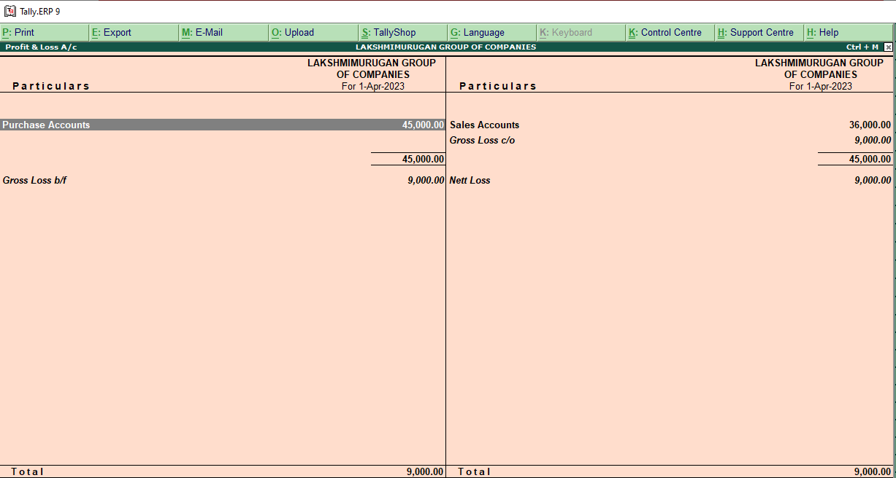

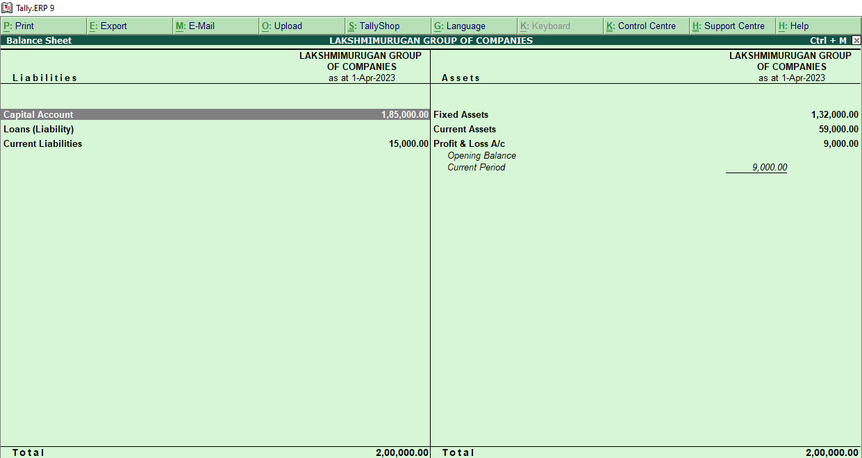

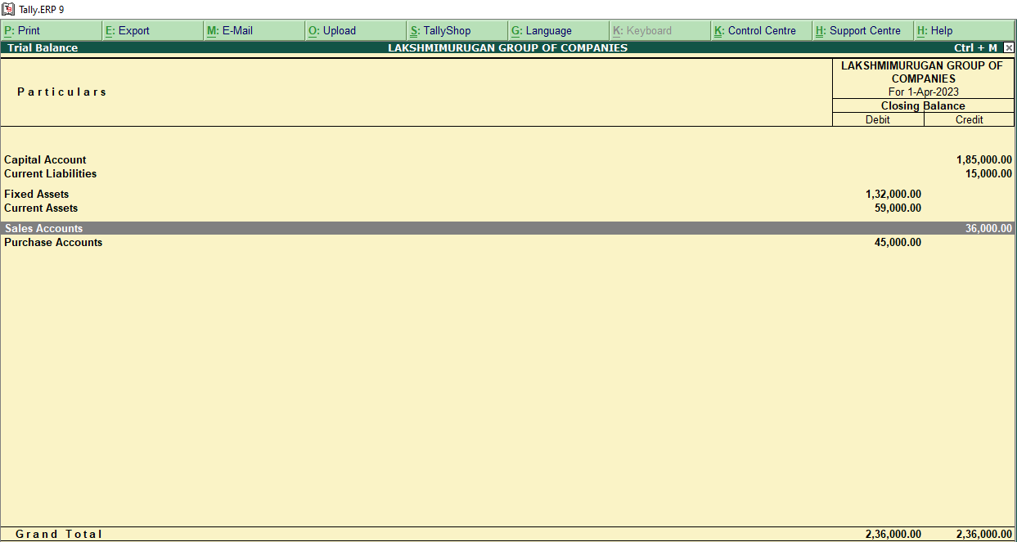

PROJECT 2 COMPLECATED TALLY ERP 9 PROJECT

|  |  |  |  |  |
| --- | --- | --- | --- | --- |
| DATE | PARTICULARS DETAIL | ENTRY | AMOUNT | VOUCHER |
| APR 1 | BUSINESS STARTS WITH CAPITAL | CASH A/C DR  TO CAPITAL A/C | 1000000  1000000 | RECEIPT(F6) |
| APR 1 | AMOUNT DEPOSITED IN THE BANK | BANK A/C DR  TO CASH A/C | 700000  700000 | CONTRA(F4) |
| APR 1 | TOYS BOUGHT FOR CASH | PURCHASE A/C DR  TO CASH A/C | 200000  200000 | PURCHASE (F9) |
| APR 1 | TOYS SOLD FOR CASH | CASH A/C DR  TO SALES A/C | 125000  125000 | SALES (F8) |
| APR 1 | LOAN TAKEN 12% RATE OF INTREST | BANK A/C DR  TO LOAN ACCOUNT | 800000  800000 | RECEIPT (F6) |
| APR 1 | BUYING A MACHINARY AND BUILDING BY USING CHECK | BUILDING SHED ACCOUNT  MACHINARY ACCOUNT DR  TO BANK ACCOUNT | 500000  700000  1200000 | PAYMENTS (F5) |
| APR 1 | BUYING A RAW METERIAL ON CREDIT | RAW METERIAL GOOD DR  TO SUPREME PLASTICS LIMITED | 100000  100000 | PURCHASE (F9) |
| APR 1 | TOYS SOLD ON CREDIT | RELIABLE SOUND BUYERS & CO DR  TO SALE ACCOUNT | 127000  127000 | SALES(F8) |
| APR 1 | SUNDRY EXPENSES | SUNDRY EXPENSES DR  TO CASH A/C | 32000  32000 | PAYMENT(F5) |

JOURNEL ENTRIES FOR THIS SUM

CASH ACCOUNT

LEDGER CREATION

|  |  |  |  |  |  |  |  |
| --- | --- | --- | --- | --- | --- | --- | --- |
| DATE | PARTICULARS | J.F | AMOUNT | DATE | PARTICULARS | J.F | AMOUNT |
| APR 1 | TO CAPITAL A/C |  | 1000000 | APR 1 | BY BANK |  | 700000 |
| APR 1 | TO SALES |  | 125000 | APR 1 | BY PURCHASES |  | 200000 |
|  |  |  |  | APR 1 | BY SUNDRY EXPENSES |  | 32000 |
|  |  |  |  | APR 1 | BY BALANCE C/D |  | 193000 |
|  |  |  | 1125000 |  |  |  | 1125000 |

CAPITAL ACCOUNT

|  |  |  |  |  |  |  |  |
| --- | --- | --- | --- | --- | --- | --- | --- |
| DATE | PARTICULARS | J.F | AMOUNT | DATE | PARTICULARS | J.F | AMOUNT |
| APR 1 | TO BALANCE C/D |  | 1000000 | APR 1 | BY CASH |  | 1000000 |
|  |  |  | 1000000 |  |  |  | 1000000 |

|  |  |  |  |  |  |  |  |
| --- | --- | --- | --- | --- | --- | --- | --- |
| DATE | PARTICULARS | J.F | AMOUNT | DATE | PARTICULARS | J.F | AMOUNT |
| APR 1 | TO CASH |  | 700000 | APR 1 | BY BUILDING SHED |  | 500000 |
|  | TO 12 % LOAN |  | 800000 |  | BY MACHINARY |  | 700000 |
|  |  |  |  |  | BY BALANCE C/D |  | 300000 |
|  |  |  | 1500000 |  |  |  | 1500000 |

PURCHASE ACCOUNT

BANK ACCOUNT

|  |  |  |  |  |  |  |  |
| --- | --- | --- | --- | --- | --- | --- | --- |
| DATE | PARTICULARS | J.F | AMOUNT | DATE | PARTICULARS | J.F | AMOUNT |
| APR 1 | TO CASH |  | 200000 |  | BY BALANCE C/D |  | 200000 |
|  |  |  | 200000 |  |  |  | 200000 |

SALES ACCOUNT

|  |  |  |  |  |  |  |  |
| --- | --- | --- | --- | --- | --- | --- | --- |
| DATE | PARTICULARS | J.F | AMOUNT | DATE | PARTICULARS | J.F | AMOUNT |
|  |  |  |  | APR 1 | BY CASH |  | 125000 |
|  |  |  |  |  | BY RELIABLE SOUND |  | 127000 |
|  |  |  | 252000 |  |  |  | 252000 |

LOAN ACCOUNT

|  |  |  |  |  |  |  |  |
| --- | --- | --- | --- | --- | --- | --- | --- |
| DATE | PARTICULARS | J.F | AMOUNT | DATE | PARTICULARS | J.F | AMOUNT |
|  | BY BALANCE C/D |  | 800000 | APR 1 | BY BANK |  | 800000 |
|  |  |  | 800000 |  |  |  | 800000 |

BUILDING SHED ACCOUNT

|  |  |  |  |  |  |  |  |
| --- | --- | --- | --- | --- | --- | --- | --- |
| DATE | PARTICULARS | J.F | AMOUNT | DATE | PARTICULARS | J.F | AMOUNT |
| APR 1 | TO BUILDING |  | 500000 |  | BY BALANCE C/D |  | 500000 |
|  |  |  | 500000 |  |  |  | 500000 |

MACHINARY ACCOUNT

|  |  |  |  |  |  |  |  |
| --- | --- | --- | --- | --- | --- | --- | --- |
| DATE | PARTICULARS | J.F | AMOUNT | DATE | PARTICULARS | J.F | AMOUNT |
| APR 1 | TO BANK |  | 700000 |  | BY BALANCE C/D |  | 700000 |
|  |  |  | 700000 |  |  |  | 700000 |

RAW METERIAL ACCOUNT

|  |  |  |  |  |  |  |  |  |  |  |  |
| --- | --- | --- | --- | --- | --- | --- | --- | --- | --- | --- | --- |
| DATE | PARTICULARS | | J.F | AMOUNT | | DATE | PARTICULARS | | | J.F | AMOUNT |
| APR 1 | TO SUPREME PLASTICS | |  | 100000 | |  | BY BALANCE C/D | | |  | 100000 |
|  |  | |  |  | |  |  | | |  | 100000 |
| DATE | | PARTICULARS | J.F | AMOUNT | DATE | | PARTICULARS | J.F | AMOUNT | |
|  | | BY BALANCE C/D |  | 100000 | APR 1 | | BY RAW METERIAL |  | 100000 | |
|  | |  |  | 100000 |  | |  |  | 100000 | |

RELIABLE SOUND BUYERS &AND COMPANY ACCOUNTANT

|  |  |  |  |  |  |  |  |
| --- | --- | --- | --- | --- | --- | --- | --- |
| DATE | PARTICULARS | J.F | AMOUNT | DATE | PARTICULARS | J.F | AMOUNT |
| APR 1 | TO SALES |  | 127000 |  | BY BALAMNCE C/D |  | 127000 |
|  |  |  | 127000 |  |  |  | 127000 |

SUNDRY EXPENSES ACCOUNT

|  |  |  |  |  |  |  |  |
| --- | --- | --- | --- | --- | --- | --- | --- |
| DATE | PARTICULARS | J.F | AMOUNT | DATE | PARTICULARS | J.F | AMOUNT |
| APR 1 | TO CASH |  | 32000 |  | BY BALANCE C/D |  | 32000 |
|  |  |  | 32000 |  |  |  | 32000 |

TRIAL BALANCE

|  |  |  |
| --- | --- | --- |
| PARTICULARS | DEBIT | CREDIT |
| CASH ACCOUNT | 193000 |  |
| CAPITAL |  | 1000000 |
| BANK | 300000 |  |
| PURCHASE | 200000 |  |
| SALES |  | 252000 |
| LOAN ACCOUNT |  | 800000 |
| BUILDING SHED ACCOUNT | 500000 |  |
| MACHINARY | 700000 |  |
| RAW METERIAL ACCOUNT | 100000 |  |
| SUPREME PLASTICS COMPANY |  | 100000 |
| RELIABLE SOUND BUYERS | 127000 |  |
| SUNDRY EXPENSES ACCOUNT | 32000 |  |
| TOTAL | 2152000 | 2152000 |

BY MAKING THE FINAL ACCOUNTS

TRADING ACCOUNT

|  |  |  |  |  |  |
| --- | --- | --- | --- | --- | --- |
| DATE | PARTICULARS | AMOUNT | DATE | PARTICULARS | AMOUNT |
|  | TO PURCHASES | 200000 |  | BY SALES | 252000 |
|  | TO BUY RAW METERIALS | 100000 |  | BY GRPOSS LOSS | 48000 |
|  |  | 300000 |  |  | 300000 |

|  |  |  |  |  |  |
| --- | --- | --- | --- | --- | --- |
| DATE | PARTICULARS | AMOUNT | DATE | PARTICULARS | AMOUNT |
|  | TO GROSS LOSS | 48000 |  | BY NET LOSS | 80000 |
|  | TO INDIRECT EXPENSES | 32000 |  |  |  |
|  |  | 80000 |  |  | 80000 |

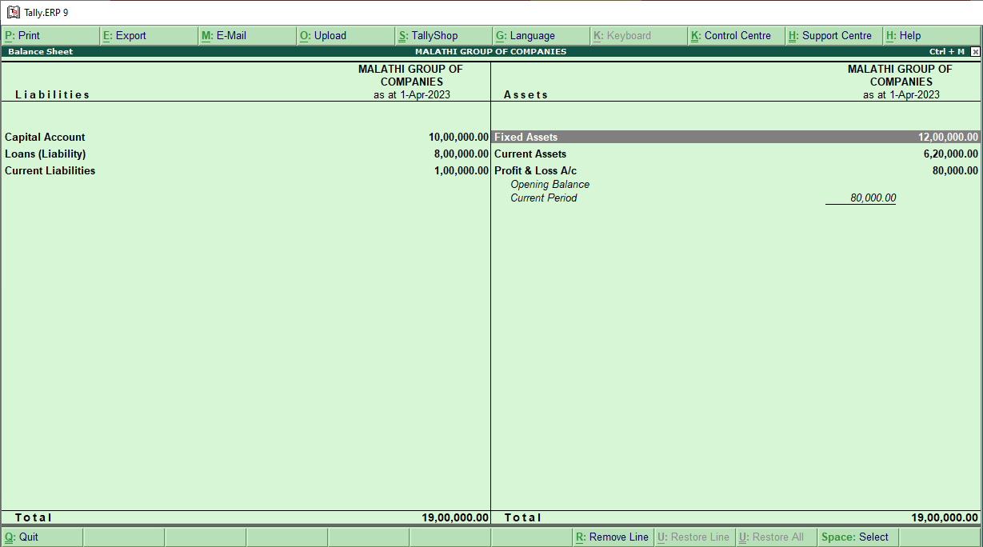

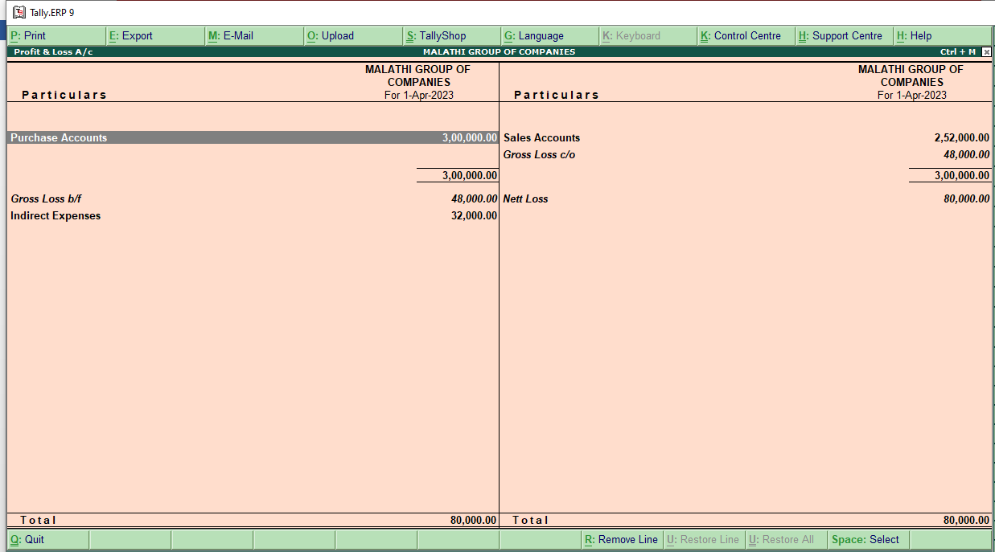

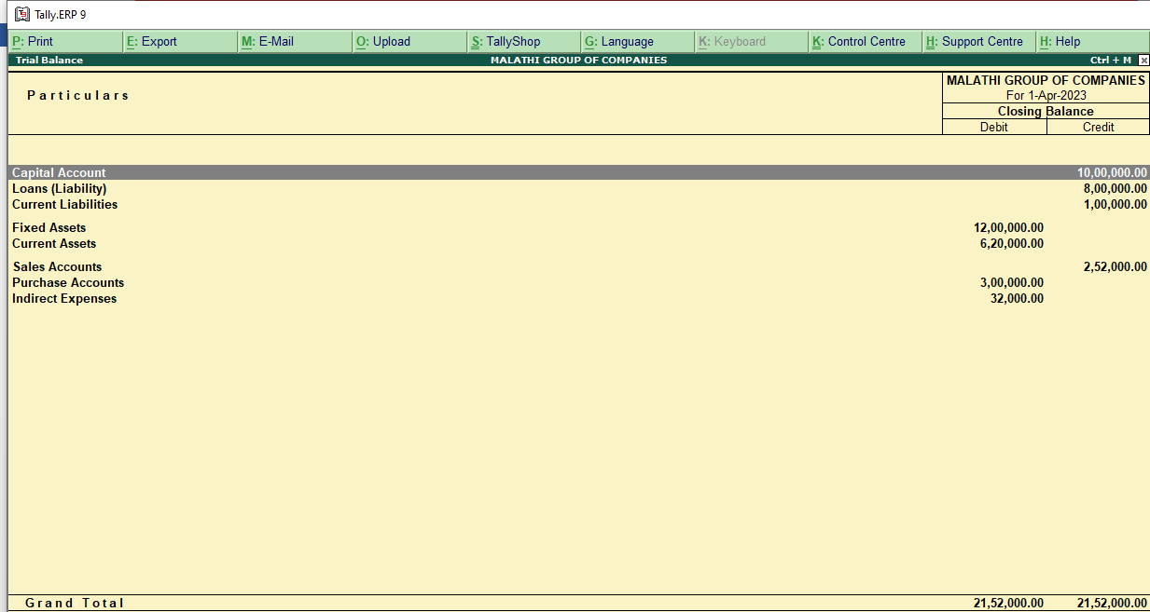

PROJECT COMPLETED